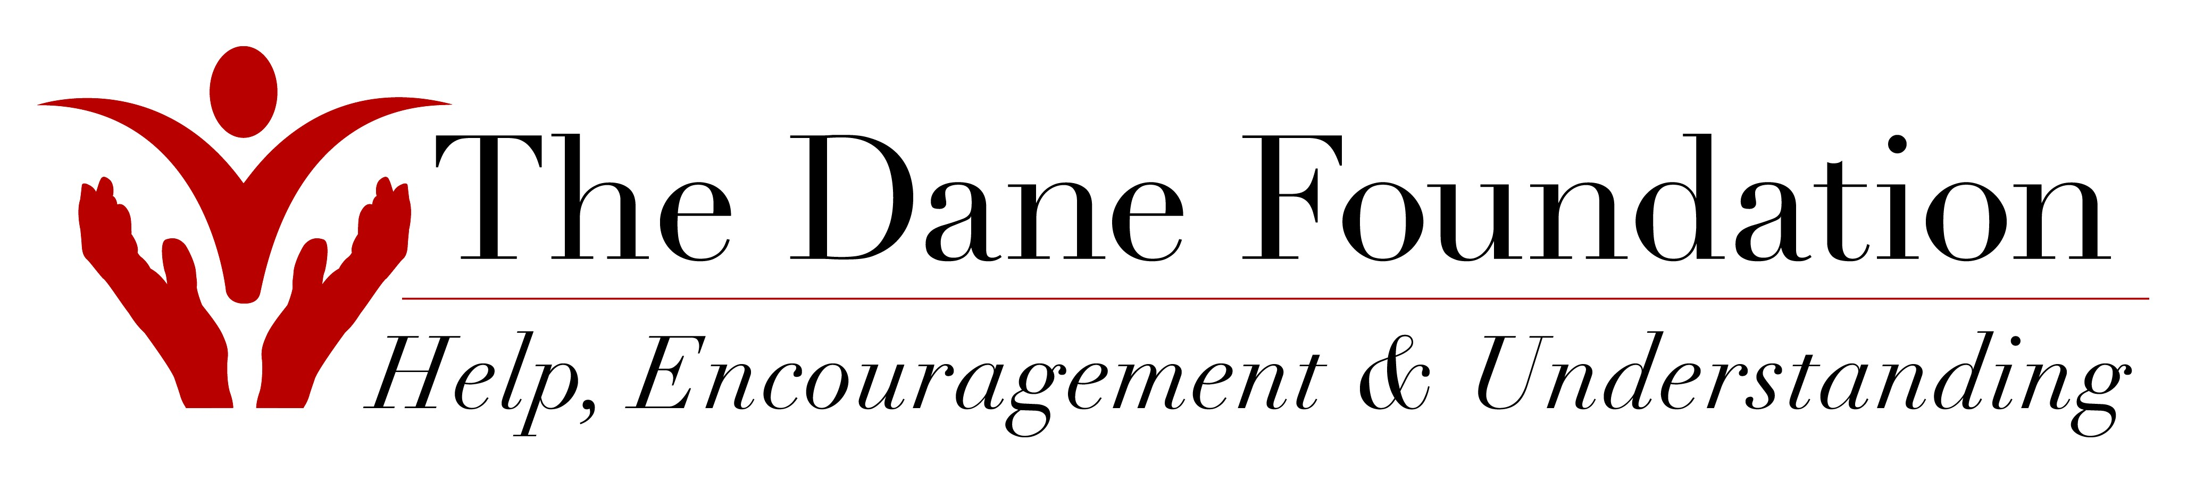
PO Box 124 Cuyahoga Falls, OH 44222

www.TheDaneFoundation.org Info@TheDaneFoundation.org

I Can Help Volunteer form

Please complete the below information and indicate any areas of service that interest you.
Please return this form to The Dane Foundation ASAP to start your volunteer journey!

Name _______________________________________________________________________

Address _____________________________________________________________________

City ________________________________ State _______________ Zip _______________

Phone _______________________________ Email _________________________________

Employer _____________________________________ Occupation _________________________

How do you prefer to be contacted? (Circle) Mail Phone Email Other __________________

Best time to contact you ______________ How did you learn about TDF? ____________________

Hours you are available? (circle all that apply) Weekdays Evenings Weekends Holidays At home

Special skills/talents/networking you can bring to TDF? ____________________________________

I am interested in the following service opportunities: (check any and all that apply)

_____ Office Work _____ Event Assistance _____ Assist with donation preparation

_____ Volunteer Guild _____ Mailings _____ Pick up donated items

_____ Youth Council _____ Speaker’s Bureau

_____ Volunteer coordination/recruitment _____ Info Booths @ Community Events

_____ Soliciting donations & sponsorships _____ Holiday Festival (December)

_____ Understanding U (January-Akron) _____ Project Elf (November-December)
_____ Tree Contest (November-December) _____ Crowns4Christ (year around)

_____ Volunteer Recognition Program (April) _____ Ms. Wheelchair USA (July – year prep)

Other ______________________________________________________________________

Please return form to The Dane Foundation

call 330-703-1183 email: Info@TheDaneFoundation.org
TDF use only: Received _______________ Contacted by__________________ Scheduled _______________

