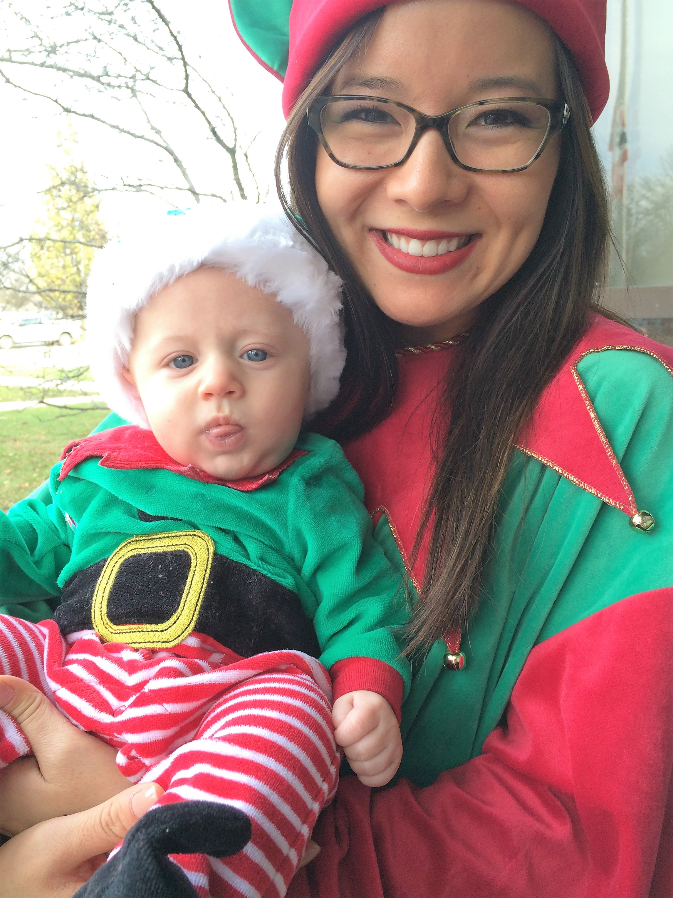
Project Elf 2024

I / WE WANT TO BE ELVES THIS HOLIDAY!

Please complete the below information with your Elf information and indicate your preference for adoption. You will be receiving a specific wish list for you to use as a shopping list. Lists will be emailed to you – gifts must be delivered to The Dane Foundation (by appointment) no later than December 8 at 10pm.

Name _______________________________________________________________________

Address _____________________________________________________________________

City ________________________________ State _______________ Zip _______________

Phone _______________________________ Email _________________________________

Company (group of elves) ______________________________________________________

How do you prefer to be contacted? (Circle) Mail Phone Email Other __________________

Best time to contact you ______________ How did you learn about TDF? ____________________

Adopting Elf/Elves Are: _____Individual ____Family _____Co-Workers _____Group

I/We are interested in adopting the following: (check any and all that apply)

_____ Individual with Disabilities (any age)
_____ man _____ woman _____either

How many individuals can you adopt this year?_________

_____ Family with child/children with Disabilities

Other ______________________________________________________________________

Please return form to The Dane Foundation via email at Info @TheDaneFoundation.org

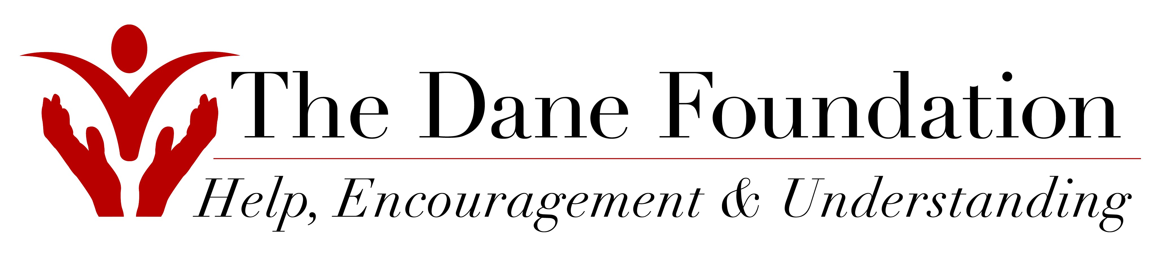
Questions? Call us at 330-703-1183
www.TheDaneFoundation.org

TDF use only: Received __________ Contacted by____________ Assigned to _________________________________

